Základní škola Olomouc
příspěvková organizace
Mozartova 48, 779 00 Olomouc
tel.: 585 427 142, 775 116 442; fax: 585 422 713
e-mail: kundrum@centrum.cz; www.zs-mozartova.cz



Projekt: ŠKOLA RADOSTI, ŠKOLA KVALITY
Registrační číslo projektu: CZ.1.07/1.4.00/21.3688

EU PENÍZE ŠKOLÁM
Operační program Vzdělávání pro konkurenceschopnost

Autor: | Mgr. Erik Vilímec
Vzdělávací oblast: | Jazyk a jazyková komunikace
Vzdělávací obor: | Anglický jazyk
Vyučovací předmět: | Anglický jazyk
Ročník: | 6.
Tematická oblast: | Konverzační témata
Téma hodiny: | Describing your room - Popis pokoje
Označení DUM: | VY_32_INOVACE_21.04.VIL.AJ.6
Vytvořeno: | 26. 09. 2012

Describing your room

Popis pokoje
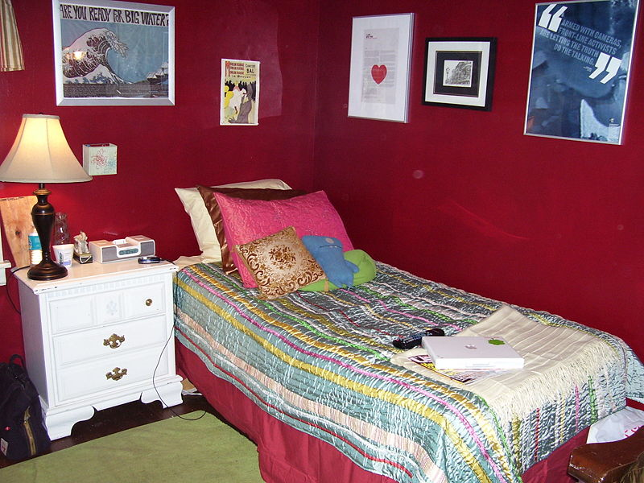

obr.1

1. Vocabulary. Rooms and places in the house or flat. Read and match. (Spopj věty s místnostmi)
a) People eat their breakfast, a bedroom
lunch or dinner here.
b) People sleep here. a bathroom
c) Children sleep, play and
do their homework here. a dining room
d) People cook here.
e) People sit and watch TV here. a living room
f) People hang their jackets and
take off their shoes here. a kitchen
g) People wash their hands, clean
their teeth, have a shower or bath here. a children´s room

2. Vocabulary. Furniture and things. Sort out the expressions.
(Rozřaď slova do správných skupin.)
wardrobe attic rug dining room kitchen shelf plant bathroom
bookcase computer bedside table cellar bed living room
radio clock toilet lamp children´s room poster cloakroom
pillows shower toys chair hall books balcony picture
furniture | things | rooms and places

3. Prepositions. Join the expressions. (Spoj výrazy.)
in za
by naproti
next to v
opposite u
under pod
over vedle
behind nad

4. There is/are. Complete the sentences with IS or ARE. (Doplň věty
pomocí IS nebo ARE).

Paul´s room
This is Paul´s room. His bedroom is not very big and it is next to his parents´ bedroom.
There __________ a guitar on the bed, and there are three magazines. There ___________ a bedside table next to his bed on the left, and there ___________ a wardrobe on the right. There ___________ some clothes and two boxes in the wardrobe.
There ___________ a big brown desk in Stephen´s room. There ___________ three books, a computer, two pens and some CD´s on the desk. There __________ a black radio next to the computer. There __________ a tennis racquet in a black bag and red football boots under the desk. Next to the desk, there __________ a blue bag and a blue chair. There __________ a white ball on the floor.
There __________ two posters on the walls. There ___________ an animal poster between the desk and the wardrobe. There ___________ an eagle, a cobra and an elephant in the picture.

5. Write a description of the room. (Popiš pokoj pomocí vazby ´There
is/are + předložka´.)
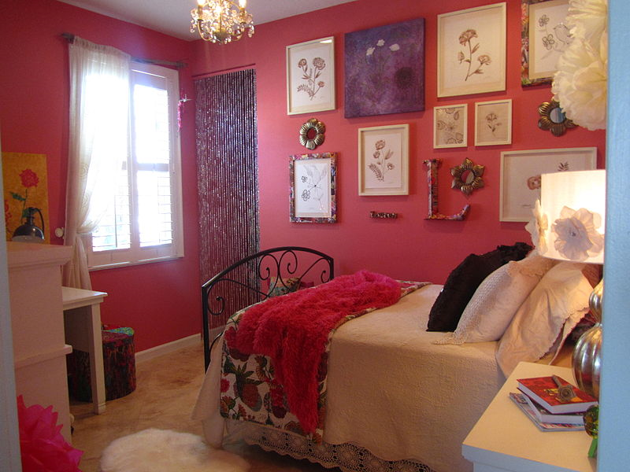
obr.1
__________________________________________________________________________________
__________________________________________________________________________________
__________________________________________________________________________________
__________________________________________________________________________________
__________________________________________________________________________________
__________________________________________________________________________________
__________________________________________________________________________________
__________________________________________________________________________________
__________________________________________________________________________________
__________________________________________________________________________________
__________________________________________________________________________________
6. My room. Draw and describe your bedroom. (Nakresli a popiš svůj
pokojíček.)

____________________________________________________________________
____________________________________________________________________
____________________________________________________________________
____________________________________________________________________
____________________________________________________________________
____________________________________________________________________
____________________________________________________________________
____________________________________________________________________
____________________________________________________________________
____________________________________________________________________
7. Describe the rooms. (Popiš pokoje, použij vazbu ´there is/are´.)
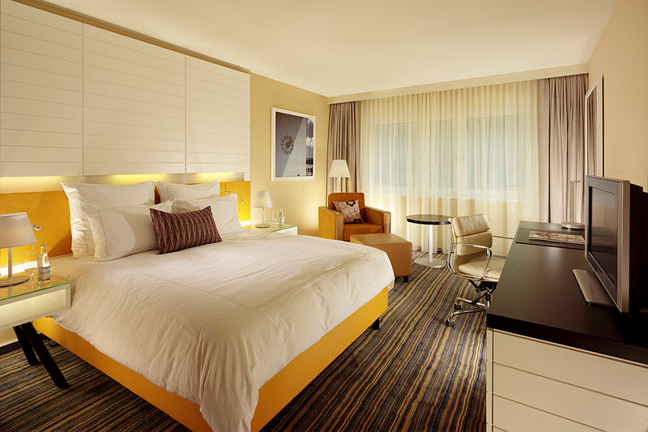
obr.1
A

obr.2
B

Základní škola Olomouc
příspěvková organizace
Mozartova 48, 779 00 Olomouc
tel.: 585 427 142, 775 116 442; fax: 585 422 713
e-mail: kundrum@centrum.cz; www.zs-mozartova.cz

Seznam použité literatury a pramenů:
HUTCHINSON, T. Project 2 – třetí vydání. Oxford : OUP, 2008. ISBN 978-0-19-476415-5. s. 6.

Použité zdroje:

Strana 2
[Obr.1][cit. 2012-23-09]. Dostupný pod licencí Creative Commons na WWW:
<http://commons.wikimedia.org/wiki/File:Red_bedroom.jpg>.

Strana 5
[Obr.1][cit. 2012-23-09]. Dostupný pod licencí Creative Commons na WWW:
http://commons.wikimedia.org/wiki/File:LoloUOroom.jpg?uselang=cs>.
Strana 7
[Obr.1][cit. 2012-23-09]. Dostupný pod licencí Creative Commons na WWW:
http://commons.wikimedia.org/wiki/File:LoloUOroom.jpg?uselang=cs>.
[Obr.2][cit. 2012-23-09]. Dostupný pod licencí Creative Commons na WWW: <http://commons.wikimedia.org/wiki/File:SBA_Classic_Room.jpg?uselang=cs>.

