Základní škola Olomouc
příspěvková organizace
Mozartova 48, 779 00 Olomouc
tel.: 585 427 142, 775 116 442; fax: 585 422 713
e-mail: kundrum@centrum.cz; www.zs-mozartova.cz



Projekt: ŠKOLA RADOSTI, ŠKOLA KVALITY
Registrační číslo projektu: CZ.1.07/1.4.00/21.3688

EU PENÍZE ŠKOLÁM
Operační program Vzdělávání pro konkurenceschopnost

Autor: | Mgr. Erik Vilímec
Vzdělávací oblast: | Jazyk a jazyková komunikace
Vzdělávací obor: | Anglický jazyk
Vyučovací předmět: | Anglický jazyk
Ročník: | 6.
Tematická oblast: | Konverzační témata
Téma hodiny: | Everyday life, my day – Každodenní život, můj den
Označení DUM: | VY_32_INOVACE_21.10.VIL.AJ.6
Vytvořeno: | 11. 02. 2013

Everyday life, my day
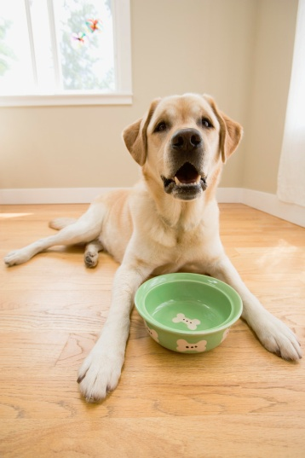
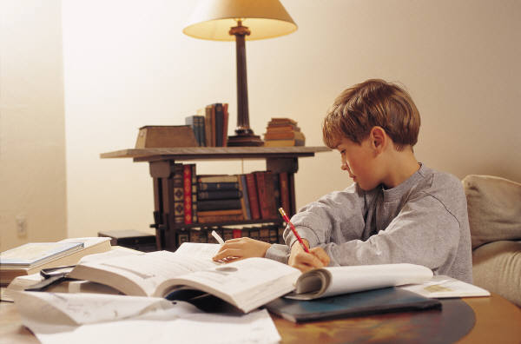

(Každodenní život, můj den)

1. Vocabulary. Complete the bubbles with the correct phrases.
Doplň do bublin vhodné fráze.
A) in the morning
wake up fall asleep have dinner get up get dressed have breakfast leave school wash your face go to school brush your teeth go to bed take the bus to school
in the morning

B) in the afternoon
finish school relax put on your pyjamas practise the piano
have a football practice do your homework set the table
have a shower watch TV go out with friends feed your pet

in the afternoon

C) in the evening
fall asleep go to bed have dinner get up
read a book have breakfast watch TV put on your pyjamas
brush your teeth go out with friends have a shower
in the evening

D) housework
wash up cook the dinner listen to music do the shopping make the bed play computer games vacuum the floor
set the table get up tidy your room take the rubbish out

housework

2. Dej odstavce do správného pořadí tak, abys utvořil souvislý
text. (pozn. pro učitele: rozstříhej ostavce, párová nebo
skupinová aktivita)
-----------------------------------------------
My daily life
-----------------------------------------------
C My name´s Clare and I go to Mozartova Primary School in Olomouc. On school days I always wake up at seven o´clock in the morning. I go to the bathroom and I wash my face, clean my teeth and comb my hair.
-----------------------------------------------
E Then I go back to my bedroom, I make my bed and I get dressed. I go downstairs and I have breakfast with my parents and my younger brother.
-----------------------------------------------
A I usually drink tea or orange juice and I have cereals with milk or some bread, butter and cheese. We listen to the radio or watch TV while we have our breakfast.
-----------------------------------------------
J I usually leave home at 7.30. I go to school with my brother. We take the bus to school. Our lessons start at eight o´clock We have a short break after each lesson and a longer break at quarter to ten.
-----------------------------------------------
G I normally have a snack, some fruit or yoghurt and a drink and I talk to my friends. I usually finish at around two o´clock.
-----------------------------------------------

-----------------------------------------------
B When I come back home from school I always feed my hamster George and I do my homework. I sometimes help my brother with his homework, but he doesn´t like it. Boys!
-----------------------------------------------
D On Tuesdays and Thursdays at four o´clock I go to Art School and I practise the piano. I love playing the piano, it is my favourite musical instrument. On Wednesdays I go to the dance class, I dance ballet.
-----------------------------------------------
F I normally come home at six o´clock and I have some time to learn to school, I go on the Internet or I play with my brother.
-----------------------------------------------
I Sometimes I help my mum cook the dinner but I usually set the table. We have dinner at about seven o´clock.
-----------------------------------------------
H After dinner I have a shower, I put on my pyjamas and I watch TV with my parents or we just sit and talk. I usually go to bed at nine o´clock and I read a book or listen to music before I fall asleep.
-----------------------------------------------

Řešení: C,E,A,J,G,B,D,F,I,H

3. Doplň slova z rámečku do textu.
cook drink come feed have do listen
clean make wash comb wake take go have
practise leave fall finish read set have put
My daily life
My name´s Clare and I go to Mozartova Primary School in Olomouc. On school days I always __________¹ up at seven o´clock in the morning. I go to the bathroom and I __________² my face, ___________³ my teeth and _____________⁴ my hair. Then I go back to my bedroom, I ____________⁵ my bed and I get dressed. I go downstairs and I ____________⁶ breakfast with my parents and my younger brother.
I usually ____________⁷ tea or orange juice and I have cereals with milk or some bread, butter and cheese. We ____________⁸ to the radio or watch TV while we have our breakfast.
I usually ____________⁹ home at 7.30. I go to school with my brother. We ____________¹⁰ the bus to school. Our lessons start at eight o´clock. We have a short break after each lesson and a longer break at quarter to ten. I normally _____________¹¹ a snack, some fruit or yoghurt and a drink and I talk to my friends. We usually _____________¹² school at about two o´clock.
When I come back home from school I always ____________¹³ my hamster George and I _____________¹⁴ my homework. I sometimes help my brother with his homework, but he doesn´t like it. Boys!
On Tuesdays and Thursdays at four o´clock I go to Art School and I ______________¹⁵ the piano. I love playing the piano, it is my favourite musical instrument. On Wednesdays I ____________¹⁶ to the dance class, I dance ballet.
I normally _____________¹⁷ home at six o´clock and I have some time to learn for school, I go on the Internet or I play with my brother. Sometimes I help my mum ____________¹⁸ the dinner but I usually ____________¹⁹ the table. We have dinner at about seven o´clock.
After dinner I ___________²⁰ a shower, I ______________²¹ on my pyjamas and I watch TV with my parents or we just sit and talk. I usually go to bed at nine o´clock and I ____________²² a book or listen to music before I ____________²³ asleep.

4. Doplň odpovědi do dialogu. Procvič dialog ve dvojicích.
We normally have dinner at 6 o´clock.
I usually wake up at 6.30.
I leave home at 7.15.
The school starts at 8 o´clock.
I usually go to bed at 9 o´clock.
I take the bus to school.
I usually do my homework and I practise the piano.
I have a piano practise at 4 o´clock.
Yes, I do. I usually watch TV or I go on the Internet.
I wash my face, have breakfast, clean my teeth and I get dressed.
Yes, I do. I read a book or listen to music.
- What time do you usually wake up?
- __I usually wake up at 6.30____________________
- What do you do in the morning?
- _______________________________________________
- What time do you go to school?
- _______________________________________________
- How do you go to school?
- _______________________________________________
- When does the school start?
- _______________________________________________
- What do you do after school?
- _______________________________________________
- What time do you have a piano practise?
- _______________________________________________
- When do you usually have dinner?
- _______________________________________________
- Do you watch TV in the evening?
- _______________________________________________
- When do you usually go to bed?
- ______________________________________________
- Do you read a book in bed?
- ______________________________________________

5A. Student A Použij otázky z cv. 4. Použij obrázky a
nápovědu. Ptej se partnera o každodenních věcech.
_ _ _ _ _ _ _ _ _ _ _ _ _ _ _ _ _ _ _ _ _ _ _ _ _ _ _ _ _ _ _ _ _ _ _ _ _ _ _ _ _ _ _ _ _ _ _ _ _ _ _ _ _ _ _ _ _
when/wake up?

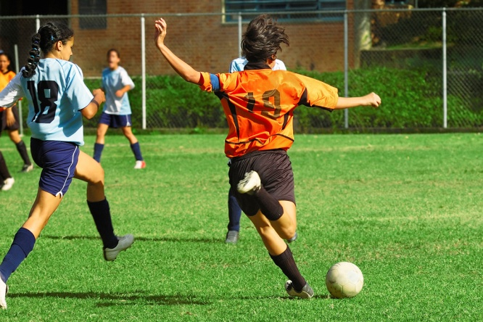
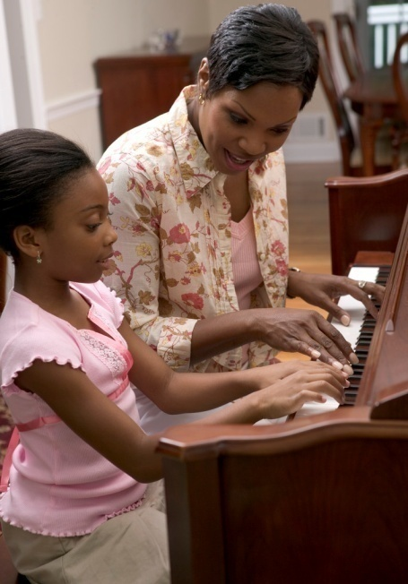
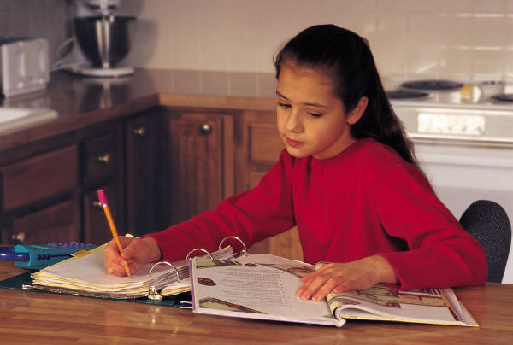
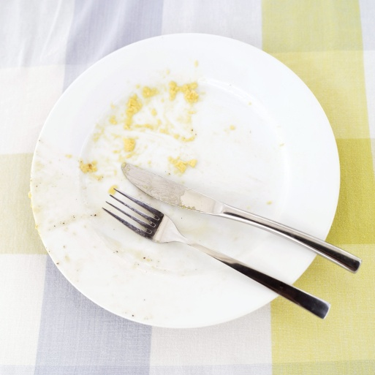
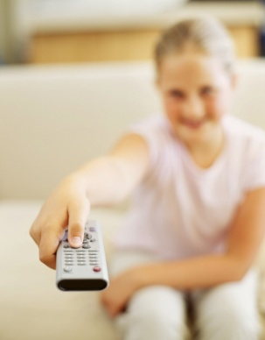
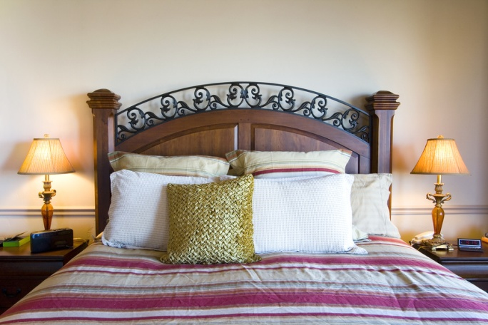

when/have breakfast?
when/take the bus to school?
when/school
start?
when/school
finish?
what/after school?
when/
piano lesson?
when?
when/have dinner?

what/after dinner?
when/have a shower?
when/go to bed?
read in bed?
when/fall asleep?

5B. Student B Použij odpovědi z cv. 4. Utvoř dialog. Odpovídej partnerovi. Použij obrázky a nápovědu.
--------------------------------------------------------------
take bus to school
7.15 a.m.
wake up
half past six
school start
8 o´clock
have breakfast
7.00 a.m.
school finish
2.00 p.m.

piano lesson
half past three
5.00 p.m.
feed the dog
after school

have a shower
before bed
watch TV/listen to music
have dinner
7 o´clock

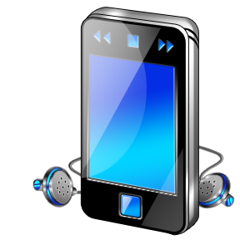

listen to music in bed
go to bed
9 o´clock
fall asleep
half past nine

6A. Student A Použij otázky z cv. 4. Použij obrázky a
nápovědu. Utvoř dialog. Ptej se partnera na každodenní
věci. Zjisti informace.
_ _ _ _ _ _ _ _ _ _ _ _ _ _ _ _ _ _ _ _ _ _ _ _ _ _ _ _ _ _ _ _ _ _ _ _ _ _ _ _ _ _ _ _ _ _ _ _ _ _ _ _ _ _ _ _ _
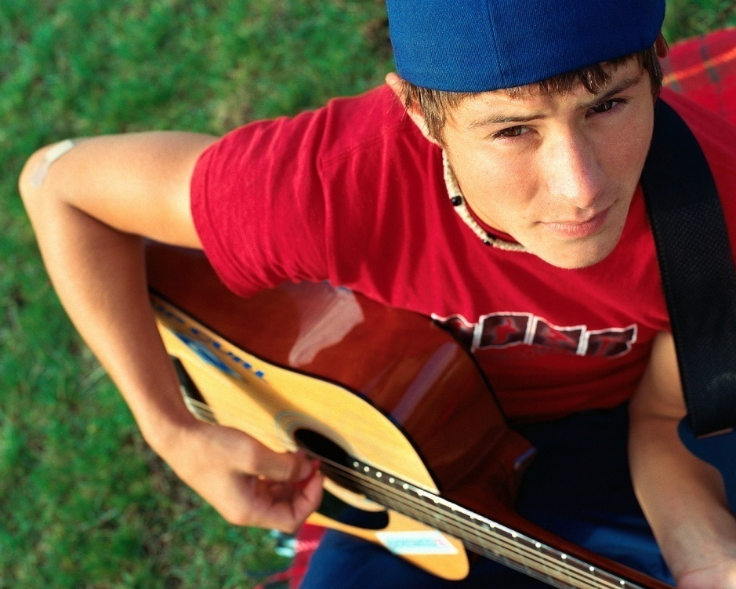
when/get up?
when/have breakfast?
when/take the bus to school?
when/school
start?
when/school
finish?
what/after school?
when?
when/have dinner?

what/after dinner?
when/have a shower?
when/go to bed?
listen to music in bed?
when/fall asleep?

when/
guitar practice?

6B. Student B Použij odpovědi z cv. 4. Utvoř dialog. Odpovídej
partnerovi. Použij obrázky a nápovědu .
_ _ _ _ _ _ _ _ _ _ _ _ _ _ _ _ _ _ _ _ _ _ _ _ _ _ _ _ _ _ _ _ _ _ _ _ _ _ _ _ _ _ _ _ _ _ _ _ _ _ _ _ _ _ _ _ _
get up/6.30 a.m.
take bus to school 7.30 a.m.
have a shower
half past seven
read a book
in bed
have breakfast
7.00 a.m.
school start 8.05 a.m.
school finish
half past two
play football
after school
half past five
have dinner
6.30 p.m.

watch TV or play PC games/after dinner
go to bed
9.00 p.m.
fall asleep
half past nine

guitar practice
4.15 p.m.

7. Podívej se na obrázky a nápovědu, popiš svůj den.
--------------------------------------------------------------
take bus to school
7.10 a.m.
get up
6.15 am
school start
8 o´clock
have breakfast
7.00 am
school finish
2.30 p.m.

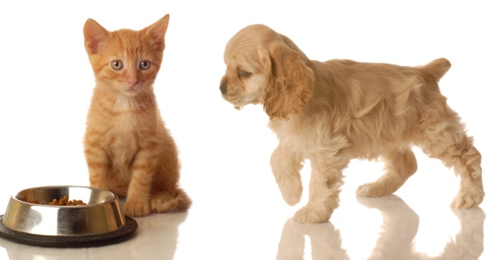
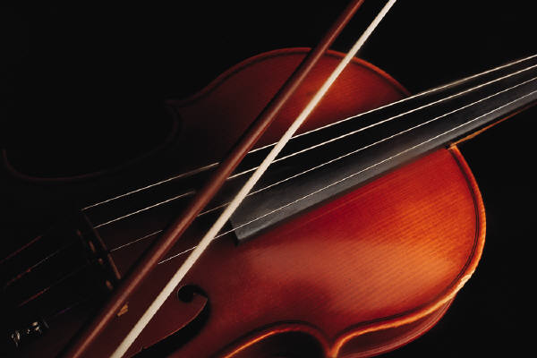
violin practice
half past three
5.00 p.m.
feed the pets
after school

8 o´clock
after dinner
have dinner
7 o´clock

have a shower
before bed

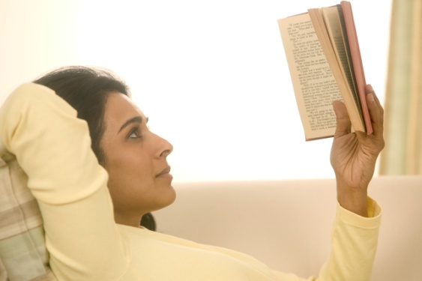

go to bed
9 o´clock
read a book
in bed
fall asleep
half past nine

8. Podívej se na obrázky a nápovědu, popiš svůj den.
--------------------------------------------------------------

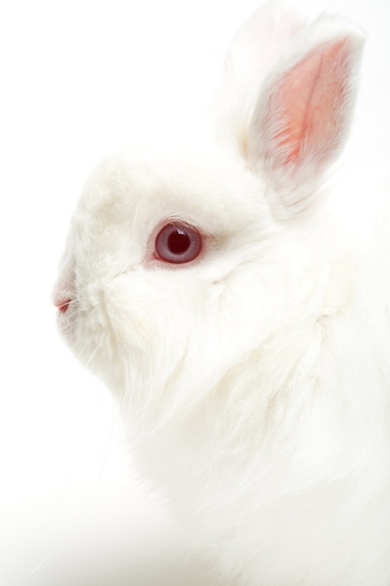
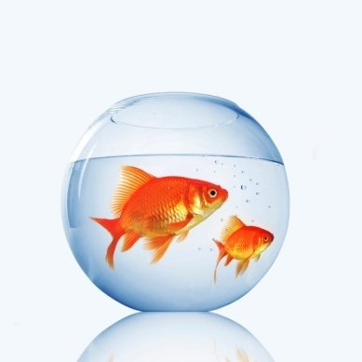
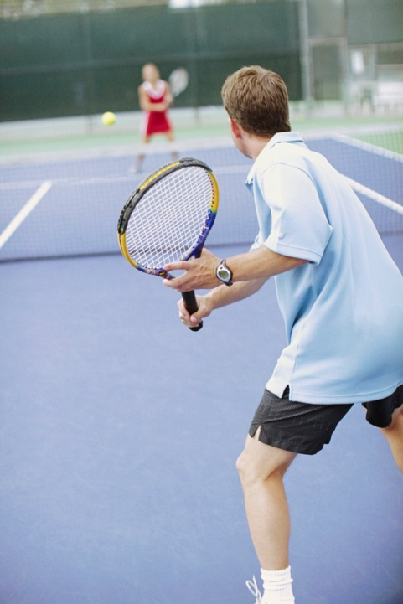
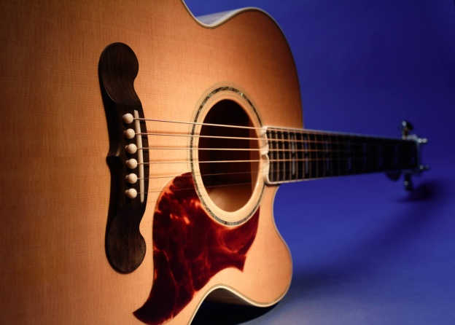
get up
6.15 a.m.
have breakfast
7.10 a.m.
by car with dad
7.35 a.m.
school start
8 00 a.m.
school finish
2.00 p.m.
feed the pets
after school
tennis practice
Monday and Thursday/three o´clock
guitar practice
Tuesday
half past three
5.30 p.m.
have dinner
7 o´clock

have a shower
after dinner
with parents
in the evening
go to bed
9 o´clock
fall asleep
half past nine

Základní škola Olomouc
příspěvková organizace
Mozartova 48, 779 00 Olomouc
tel.: 585 427 142, 775 116 442; fax: 585 422 713
e-mail: kundrum@centrum.cz; www.zs-mozartova.cz

Seznam použité literatury a pramenů:

HUTCHINSON, T. Project 2 – třetí vydání. Oxford : OUP, 2008. ISBN 978-0-19-476415-5. s. 8 - 9, 14 - 15.

Použité zdroje:

Obrazový materiál je použit z galerie obrázků a klipartů Microsoft Office.

Nečíslovaný obrazový materiál je použit z kolekce programu Microsoft Word.

