Základní škola Olomouc
příspěvková organizace
Mozartova 48, 779 00 Olomouc
tel.: 585 427 142, 775 116 442; fax: 585 422 713
e-mail: kundrum@centrum.cz; www.zs-mozartova.cz



Projekt: ŠKOLA RADOSTI, ŠKOLA KVALITY
Registrační číslo projektu: CZ.1.07/1.4.00/21.3688

EU PENÍZE ŠKOLÁM
Operační program Vzdělávání pro konkurenceschopnost

Autor: | Mgr. Erik Vilímec
Vzdělávací oblast: | Jazyk a jazyková komunikace
Vzdělávací obor: | Anglický jazyk
Vyučovací předmět: | Anglický jazyk
Ročník: | 6.
Tematická oblast: | Konverzační témata
Téma hodiny: | What are you going to do in the evening? – Co budeš dnes večer dělat?
Označení DUM: | VY_32_INOVACE_21.18.VIL.AJ.6
Vytvořeno: | 14. 05. 2013

What are you going to do in the evening?

(Co budeš dnes večer dělat?)

1. Put the words in the correct column. (Dej slova do správného
sloupečku, některá slova lze použít vícekrát).
DJ book channel painting actor musical cartoon programme actress stage sculpture documentary comedy morning show drama science fiction film magazine ceramics screen play TV news a newspaper film seats photography comic strip 3D glasses
theatre | TV | radio

literature | art | cinema

2. What´s this? Write letters. (Přečti si věty a napiš slova).

1 You come here to watch new films. c _ _ _ _ _
2 You come here to watch animals,
clowns and artists. c _ _ _ _ _
3 You watch films and programmes on it.
You switch it on and off. t _ _ _ _ _ _ _ _ _
4 You listen to programmes, music and
a DJ on it. r _ _ _ _
5 It´s taking photographs, making ceramics,
sculptures or painting pictures. a _ _
6 It´s books, magazines, newspapers and
everything you can read. l _ _ _ _ _ _ _ _ _
7 You come here to watch plays,
actors and actresses. t _ _ _ _ _ _

8 It´s a theatre play where actors
don´t speak, they use only hands, face
and body. p _ _ _ _ _ _ _ _
9 It´s the people sitting in seats
and watching a theatre play. a _ _ _ _ _ _ _

10 You must buy this before you enter
a cinema, circus or theatre. t _ _ _ _ _

3. Put the words in the correct order. (Dej slova do správného
slovosledu).

1 am / I / going to / this evening / watch TV .
___I am going to watch TV this evening.__________________
2 going to / am / I / play / this afternoon / PC games .
_________________________________________________________
3 are / you / What / going to / do / this evening ?
_________________________________________________________
4 not / I´m / going to / this evening / do my homework .
_________________________________________________________
5 is / going to / he / on Friday / play tennis .
_________________________________________________________
6 going to / Phil / is / at 8 o´clock / watch a film .
_________________________________________________________
7 are / Where / you / going to / in the evening / be ?
_________________________________________________________
8 going to / What / are / watch on TV / you / this evening ?
_________________________________________________________

4. Read the clues. Match the questions with the answers.
a) Přečti si informace v tabulce.
A B
What / evening ? watch TV
What / watch ? ice hockey match
What time / start ? 6.30 p.m.
Where / watch ? at home / with your dad

b) Spoj otázky a odpovědi.
1 What are you going to do I´m going to watch an ice
in the evening? hockey match.
2 What are you going to watch? It starts at 6.30 p.m.
3 What time does it start? I´m going to watch TV.
4 Where are you going to I´m going to watch
watch it? at home with my dad.
c) Přečti si informace v tabulce. Odpověz na otázky podobně jako ve cv. b, použij informace z tabulky.
A B
What / evening ? watch TV

What / watch ? football match
What time / start ? 7.00 p.m.
Where / watch ? at home / with your granddad

1 What are you going to do in the evening?
____________________________________________________________
2 What are you going to watch?
____________________________________________________________
3 What time does it start?
____________________________________________________________
4 Where are you going to watch it?
____________________________________________________________
5. What are you going to do in the evening? Make dialogues.
(Pracuj ve dvojicích, utvoř dialogy a použij nápovědu).
1A 1B
What / evening ? - watch TV
What / watch ? - football match
What time / start ? - 8.15 p.m.
Where / watch ? - at home / with your parents

1C 1D
What / evening ? - go to the cinema
What film / see ? - a new comedy
What time / start ? - 17.30 p.m.
Where / be ? - at the Cinema Palace
_ _ _ _ _ _ _ _ _ _ _ _ _ _ _ _ _ _ _ _ _ _ _ _ _ _ _ _ _ _ _
2A 2B
What / evening ? - go to the theatre
What play / see ? - see a comedy
What time / start ? - 7 o´clock in the evening
Where / be ? - at the National Theatre

2C 2D
What / evening ? - read a book / play PC games
What / read ? - a detective story

Where / be ? - at my grandma´s

3A 3B
What / evening ? - go to the circus
Name? - Circus Vito
What / see ? - see artists, animals and
clowns
What time / start ? - 7.30 p.m.
Where / be ? - in Forest Park

3C 3D
What / evening ? - go to a new shopping centre
Name? - Canada Shopping Centre
How many shops / there ? - 50 shops

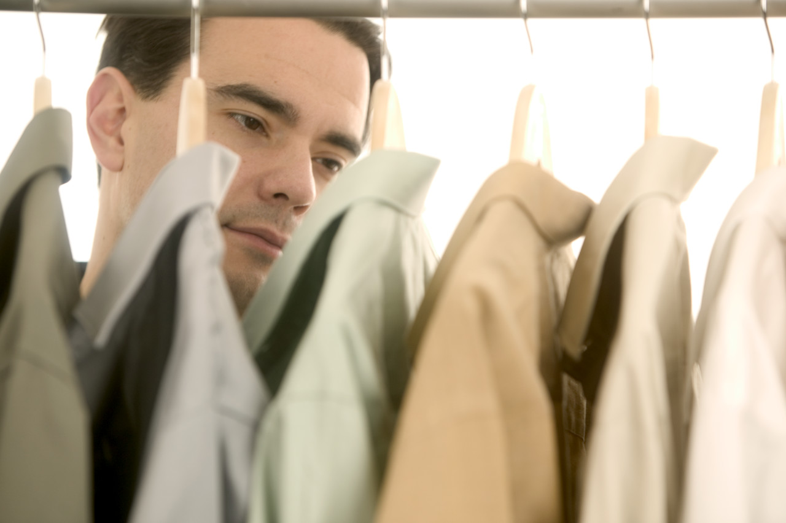
What / buy ? - new jeans and a T-shirt

_ _ _ _ _ _ _ _ _ _ _ _ _ _ _ _ _ _ _ _ _ _ _ _ _ _ _ _ _ _ _
4A 4B
What / evening ? - watch TV
What / watch ? - fantasy film
What time / start ? - 8.00 p.m.
Where / watch ? - at home / with your younger
brother

4C 4D
What / evening ? - go to the cinema
What film / see ? - a new action film
What time / start ? - 17.15 p.m.
Where / be ? - at the Cinema Star

Základní škola Olomouc
příspěvková organizace
Mozartova 48, 779 00 Olomouc
tel.: 585 427 142, 775 116 442; fax: 585 422 713
e-mail: kundrum@centrum.cz; www.zs-mozartova.cz

Seznam použité literatury a pramenů:

HUTCHINSON, T. Project 2 – třetí vydání. Oxford : OUP, 2008. ISBN 978-0-19-476415-5. s. 68-72.

HUTCHINSON, T. Project 2 – třetí vydání, Pracovní sešit. Oxford : OUP, 2008. ISBN 978-0-19-476359-2. s. 54-59.

Použité zdroje:
Obrazový materiál je použit z galerie obrázků a klipartů Microsoft Office.

Nečíslovaný obrazový materiál je použit z kolekce programu Microsoft Word.

