Základní škola Olomouc
příspěvková organizace
Mozartova 48, 779 00 Olomouc
tel.: 585 427 142, 775 116 442; fax: 585 422 713
e-mail: kundrum@centrum.cz; www.zs-mozartova.cz



Projekt: ŠKOLA RADOSTI, ŠKOLA KVALITY
Registrační číslo projektu: CZ.1.07/1.4.00/21.3688

EU PENÍZE ŠKOLÁM
Operační program Vzdělávání pro konkurenceschopnost

Autor: | Mgr. Lenka Panglová
Vzdělávací oblast: | Jazyk a jazyková komunikace
Vzdělávací obor: | Anglický jazyk
Vyučovací předmět: | Anglický jazyk
Ročník: | 7.
Tematická oblast: | Gramatické jevy
Téma hodiny: | Will for future - revision
Označení DUM: | VY_32_INOVACE_27.07.PAN.AJ.7
Vytvořeno: | 05. 12. 2012

Will – revision Name: ___________________ Date: _______

- Complete the sentences with WILL or WON´T and the verb in brackets.
not comehavenot opennot drinkdrivenot go out

A You´re tired. My dad will drive you home.
B I´m thirsty. I _____________a cup of tea.
C Nick has got a new girlfriend. He ______________ with Irina again.
D Tomorrow´s Saturday. We ____________ to the park.
E Emily _______________ the lemonade. She doesn´t like it.
F Uf, it´s freezing outside. I _____________ the window.
G I don´t like this club. I _______________ here again.

- Read the dialogue. Make questions and answer them.

A Grr. I´m so angry. What about that test?
study/for the test/on Saturday?
__Will you study for_ the test on Saturday?
___No, I won´t.__

_______________________________________________?
_____________.
B I need a new jacket so badly.
this weekend/go shopping/with me?

C But I really need to prepare
for the test.
you/on Sunday/help?
_____________________________________________?

____________. No problem.
- Offer a help. Use WILL.
She lost her pen. - __________________________.

The classroom is messy. - ____________________
______________________________________________.
She´s collecting the books. - _________________
______________________________________________.
Your teacher
Your dog is dirty. - _________________________.
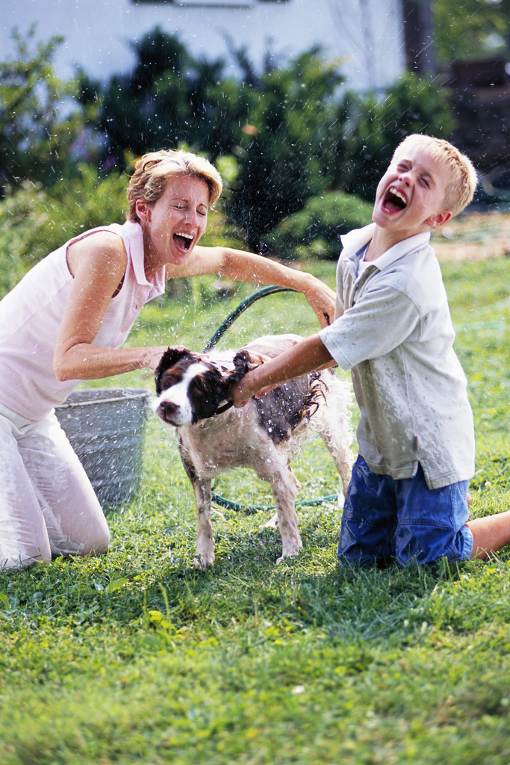
The water´s running. - _______________________.
The phone is ringing. - ______________________.

The lunch isn´t ready. - _____________________.
You´re out of potatoes and salt. - ___________
______________________________________________.
Your dog is hungry. - _______________________.

- Read and write T (true) or F (false).
Cathy´s pension
Cathy is really looking forward to her pension. When she reaches the age of 70 she will sleep long. She will take care of her grandchildren and take them for trips around the world. Perhaps she will play online games with them as well as she is keen on Angry Birds nowadays. Cathy won´t spend much money because she will share her beautiful large house with all her friends so they will save for their phone bills and shopping.

1 „Will“ is used here because the text is about an offer. ___
2 Cathy won´t have any children. ___
3 She will travel a lot. ___
4 Nowadays she doesn´t like computer games but she will play them in her pension. ___
5 Cathy will go shopping very often. ___
6 She won´t live alone. ___

KEY
Will – revision Name: ___________________ Date: _______
- Complete the sentences with WILL or WON´T and the verb in brackets.

A You´re tired. My dad will drive you home.
B I´m thirsty. I ´ll have a cup of tea.
C Nick has got a new girlfriend. He won´t go out with Irina again. D Tomorrow´s Saturday. We will go to the park.
E Emily won´t drink the lemonade. She doesn´t like it.
F Uf, it´s freezing outside. I won´t open the window.
G I don´t like this club. I won´t come here again.

- Make questions and answer them.

A Grr. I´m so angry. What about that test?
study/for the test/on Saturday?
__Will you study for_ the test on Saturday?
___No, I won´t.__

Will you go shopping this weekend with me?
Yes, I will.
B I need a new jacket so badly.
this weekend/go shopping/with me?

C But I really need to prepare
for the test.
you/on Sunday/help?
Will you help me on Sunday?

Yes, I will. No problem.
- Offer a help. Use WILL.
She lost her pen. – I´ll lend you mine.
The classroom is messy. – I´ll clean the classroom.
She´s collecting the books. – I´ll help you with that.
Your teacher
Your dog is dirty. – I´ll wash him.
The water´s running. – I´ll stop the water.
The phone is ringing. – I´ll answer it.

The lunch isn´t ready. – I´ll make lunch today.
You´re out of potatoes and salt. – I´ll go to the shops.
Your dog is hungry. – I´ll feed him.

- Read and write T (true) or F (false).
Cathy´s pension
Cathy is really looking forward to her pension. When she reaches the age of 70 she will sleep long. She will take care of her grandchildren and take them for trips around the world. Perhaps she will play online games with them as well as she is keen on Angry Birds nowadays. Cathy won´t spend much money because she will share her beautiful large house with all her friends so they will save for their phone bills and shopping.

1 „Will“ is used here because the text is about an offer. F
2 Cathy won´t have any children. F
3 She will travel a lot. T
4 Nowadays she doesn´t like computer games but she will play them in her pension. F
5 Cathy will go shopping very often. F
6 She won´t live alone. T

Základní škola Olomouc
příspěvková organizace
Mozartova 48, 779 00 Olomouc
tel.: 585 427 142, 775 116 442; fax: 585 422 713
e-mail: kundrum@centrum.cz; www.zs-mozartova.cz

Seznam použité literatury a pramenů:
HUTCHINSON, T. Project 3 Third Edition Student's Book. Oxford : OUP, 2008, ISBN 978-0-19-476310-3. s. 20-27.
HUTCHINSON, T., EDWARDS, L. Project Third edition – Workbook
+ CD-ROM. Oxford : OUP, 2008, ISBN 987 0 19 476355 4. s. 14-21, 69.

