Základní škola Olomouc
příspěvková organizace
Mozartova 48, 779 00 Olomouc
tel.: 585 427 142, 775 116 442; fax: 585 422 713
e-mail: kundrum@centrum.cz; www.zs-mozartova.cz



Projekt: ŠKOLA RADOSTI, ŠKOLA KVALITY
Registrační číslo projektu: CZ.1.07/1.4.00/21.3688

EU PENÍZE ŠKOLÁM
Operační program Vzdělávání pro konkurenceschopnost

Autor: | Mgr. Lenka Panglová
Vzdělávací oblast: | Jazyk a jazyková komunikace
Vzdělávací obor: | Anglický jazyk
Vyučovací předmět: | Anglický jazyk
Ročník: | 7.
Tematická oblast: | Gramatické jevy
Téma hodiny: | Future - revision
Označení DUM: | VY_32_INOVACE_27.09.PAN.AJ.7
Vytvořeno: | 17. 12. 2012

Future – revision Name: _______________ Date: _______

- Decide and underline the correct verb form.
(WILL or BE GOING TO)

a You are going to / will be sick if you eat too much.
b Look at that dark sky. It will / is going to rain soon.
c He will / is going to make lots of friends in his new school.
d Sharon is ill. She will not / is not going to be at the party.
e Oh, my children are real darlings. It´s their father´s birthday tomorrow so they are going to / will wash our car him.
f I hope it is going to / will rain tomorrow.

- Check the sentences, write RIGHT or correct the wrong verb form.

a I´ve got my ticket. I will go to Brazil. _____________________
b Do you think it is snowing at the weekend? ___________________
c You look tired. Have a rest. I´ll make you a cup of coffee.
_________________
d Where do you go for lunch today? _____________________________
e I can´t come because I´m going to be on holiday. _____________
f Will you hold the bag while I put my boots on? _______________

- Finish the sentences. Use BE GOING TO.
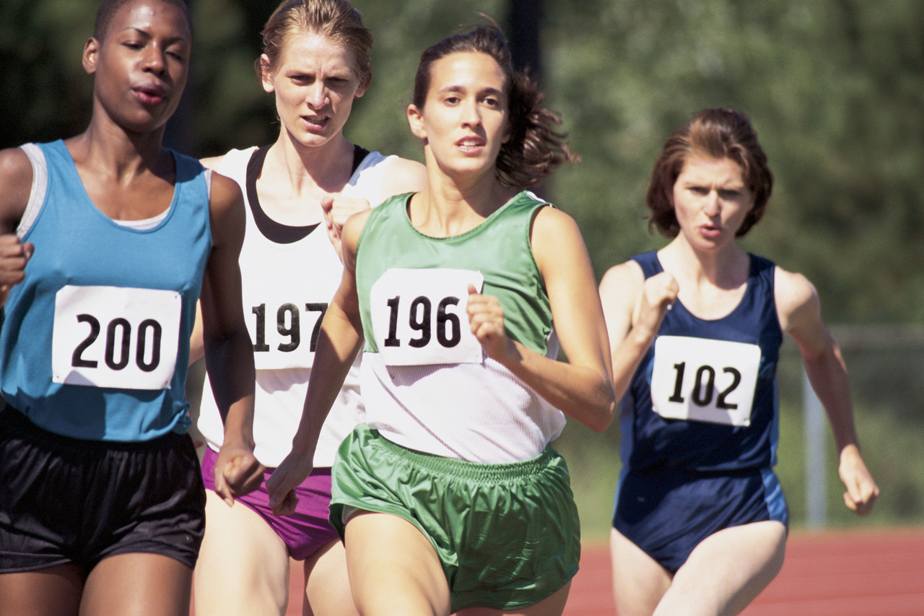

a There are 20m left to the finish. Runner 102 ______________________________________________.
b 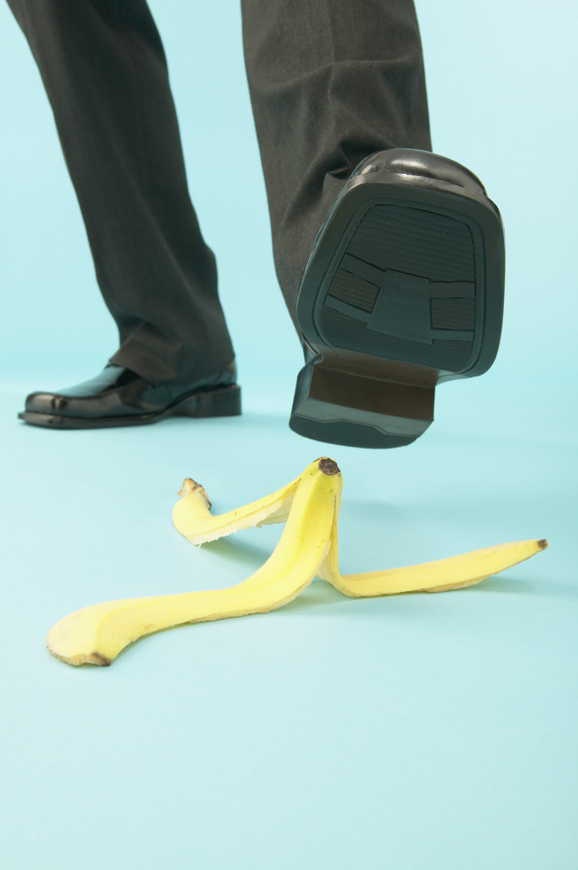 Certainly he _________________________________.

c Look at Monica. She ________________________________.
d Unbelievable! I thought it is going to be
a goal but he __________________________.

- Read the text write T (true) or F (false). Then join the pictures.

a M: What are you doing in your dressing-gown? It´s only eight
o´clock.
V: I don´t feel very well. I´m going to have an early night.
M: Oh dear. I hope you feel better in the morning.
V: So do I. I´m going to meet my new boss at ten.
M: I think I´ll make you some tea. Would you like some?
V: Oh, thanks a lot.

Ms V is wearing a beautiful dress. ____
Ms V is going to bed early. ____
Ms V hopes she won´t meet her new boss. ____

b S: It´s hard saying goodbye after so long.
A: We must keep in touch. Will you remember to send me your
new address when you get to the States?
S: Of course. I won´t probably have time next week, because
school starts the day after I´ll arrive, and I´m going to
spend the weekend with some old friends of my father´s.
A: Well, you can phone.
S: Yes, I guess so.
A: Great. I´ll wait for your call.

Mr S is going to leave. ____
Mr S is going to study in the UK. ____
Mr S thinks he´ll be busy when he comes home. ____

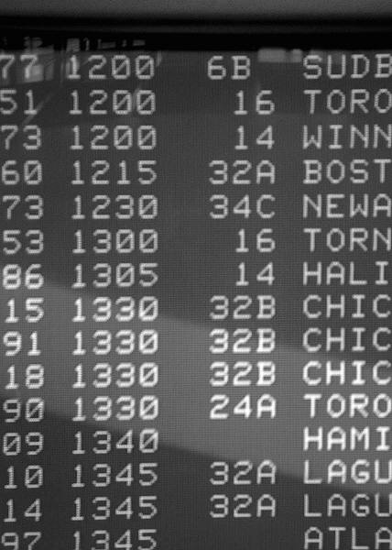____ ____
KEY
Future – revision Name: _______________ Date: _______
- Decide and underline the correct verb form.
(WILL or BE GOING TO)

a You are going to / will be sick if you eat too much.
b Look at that dark sky. It will / is going to rain soon.
c He will / is going to make lots of friends in his new school.
d Sharon is ill. She will not / is not going to be at the party.
e Oh, my children are real darlings. It´s their father´s birthday tomorrow so they are going to / will wash our car him.
f I hope it is going to / will rain tomorrow.

- Check the sentences, write RIGHT or correct the wrong verb form.

a I´ve got my ticket. I will go to Brazil. am going to (to go)
b Do you think it is snowing at the weekend? will
c You look tired. Have a rest. I´ll make you a cup of coffee.
RIGHT
d Where do you go for lunch today? are you going (to go)
e I can´t come because I´m going to be on holiday. RIGHT
f Will you hold the bag while I put my boots on? RIGHT

- Finish the sentences. Use BE GOING TO.

a There are 20m left to the finish. Runner 102
isn´t going to win the race.

b Certainly he ´s going to fall/slip.
c Look at Monica. She ´s going to blow the candle.
d Unbelievable! I thought it is going to be
a goal but he ´s going to catch it.

- Read the text write T (true) or F (false). Then join the pictures.

a M: What are you doing in your dressing-gown? It´s only eight
o´clock.
V: I don´t feel very well. I´m going to have an early night.
M: Oh dear. I hope you feel better in the morning.
V: So do I. I´m going to meet my new boss at ten.
M: I think I´ll make you some tea. Would you like some?
V: Oh, thanks a lot.

Ms V is wearing a beautiful dress. F
Ms V is going to bed early. T
Ms V hopes she won´t meet her new boss. F

b S: It´s hard saying goodbye after so long.
A: We must keep in touch. Will you remember to send me your
new address when you get to the States?
S: Of course. I won´t probably have time next week, because
school starts the day after I´ll arrive, and I´m going to
spend the weekend with some old friends of my father´s.
A: Well, you can phone.
S: Yes, I guess so.
A: Great. I´ll wait for your call.

Mr S is going to leave. T
Mr S is going to study in the UK. F
Mr S thinks he´ll be busy when he comes home. T

b a
Základní škola Olomouc
příspěvková organizace
Mozartova 48, 779 00 Olomouc
tel.: 585 427 142, 775 116 442; fax: 585 422 713
e-mail: kundrum@centrum.cz; www.zs-mozartova.cz

Seznam použité literatury a pramenů:
HUTCHINSON, T. Project 3 Third Edition Student's Book. Oxford : OUP, 2008, ISBN 978-0-19-476310-3. s. 20-31.
HUTCHINSON, T., EDWARDS, L. Project Third edition – Workbook
+ CD-ROM. Oxford : OUP, 2008, ISBN 987 0 19 476355 4. s. 14-23, 69-70.
NAYLOR, H., MURPHY, R. Essential Grammar in Use Supplementary Exercises With key. Cambridge : CUP, 1996. ISBN 10: 052146997X. s. 35.

