Základní škola Olomouc
příspěvková organizace
Mozartova 48, 779 00 Olomouc
tel.: 585 427 142, 775 116 442; fax: 585 422 713
e-mail: kundrum@centrum.cz; www.zs-mozartova.cz



Projekt: ŠKOLA RADOSTI, ŠKOLA KVALITY
Registrační číslo projektu: CZ.1.07/1.4.00/21.3688

EU PENÍZE ŠKOLÁM
Operační program Vzdělávání pro konkurenceschopnost

Autor: | Mgr. Erik Vilímec
Vzdělávací oblast: | Jazyk a jazyková komunikace
Vzdělávací obor: | Anglický jazyk
Vyučovací předmět: | Anglický jazyk
Ročník: | 9.
Tematická oblast: | Konverzační témata
Téma hodiny: | Expressing likes and dislikes (Vyjádření libosti a nelibosti)
Označení DUM: | VY_32_INOVACE_31.04.VIL.AJ.9
Vytvořeno: | 24. 09. 2013

Talking about you, expressing likes and dislikes

1. Opakování – expressing likes and dislikes. Dej fráze do
správného sloupce.
she is interested in art he likes I love
she prefers I enjoy swimming is OK
jogging can be fun music is important to him
I´m into cycling I dislike she hates running
I´m not interested in I can´t stand golf
It´s not important to me I don´t prefer sports to art
board games are boring to her I never go window shopping I don´t enjoy watching athletics making ceramics is not bad
positive | neutral | negative

2. Utvoř otázky, dej slova do správného slovosledu. (Make
questions. Put the words in the correct word order.)

1. often / sports / do / how / go / to / the / you / centre?
__________________________________________________________
2. do / piano / you / where / practice / usually / the?
__________________________________________________________
3. boat / do / like / why / sailing / your / you?
__________________________________________________________
4. your /are /time /your /favourite /what /activities /free /in?
__________________________________________________________
5. skydiving / you / done / ever / have?
__________________________________________________________
6. watching /you /practising /prefer /sports /do /TV /on /to /them?
__________________________________________________________
7. don´t / animals / you / like / why / keeping?
__________________________________________________________
8. do / when / usually / you / up / at / get / weekends?
__________________________________________________________
9. you / with / play / do / who / chess?
__________________________________________________________
10. to / sports / do / which / prefer / play / you?
__________________________________________________________
3. Otázky. Přiřaď otázky k odpovědím. Procvič otázky a
odpovědi ve dvojicích.
1. How often do you go to the sports centre? ___
2. Where do you usually practice the piano? ___
3. Why do you like going fishing? ___
4. What are your favourite activities in your free time? ___
5. Have you ever done bungee jumping? ___
6. Do you prefer watching sports on TV to practising them? ___
7. Why don´t you like keeping animals? ___
8. When do you usually get up at weekends? ___
9. Who do you play chess with? ___
10. Which sports do you prefer to play? ___

a) Yes, I have. I´ve once jumped off a bridge when I was on
holiday in France.
b) Because I don´t have time to feed them and play with.
c) I often play with my grandpa and my father.
d) I enjoy practicing them, but I never watch sports on TV,
it´s boring.
e) It´s exciting and I like a beautiful countryside.
f) I am into roller-blading and jogging.
g) Twice a week. On Tuesdays and Thursdays. I play squash.
h) I often practice at home and I go to a music school on
Wednesdays.
i) I get up very late at about eleven o´clock.
j) Athletics is important to and I´m interested in climbing.

4. Role-play (Prompt card activity). Pracuj ve dvojicích, ptej
se a odpovídej.

1A
- sports – football and swimming, O.K.,
volleyball, boring / animals – love a lot

- am into / ride a horse
- fun / interesting
- every day after school
- on Horseshoe Farm

- - - - - - - - - - - - - - - - - - - - - - - - - - - - - - -

1B
- which activities / prefer ?
- which / animals / like ?
- why / like ?
- when / ride ?
- where ?

2A
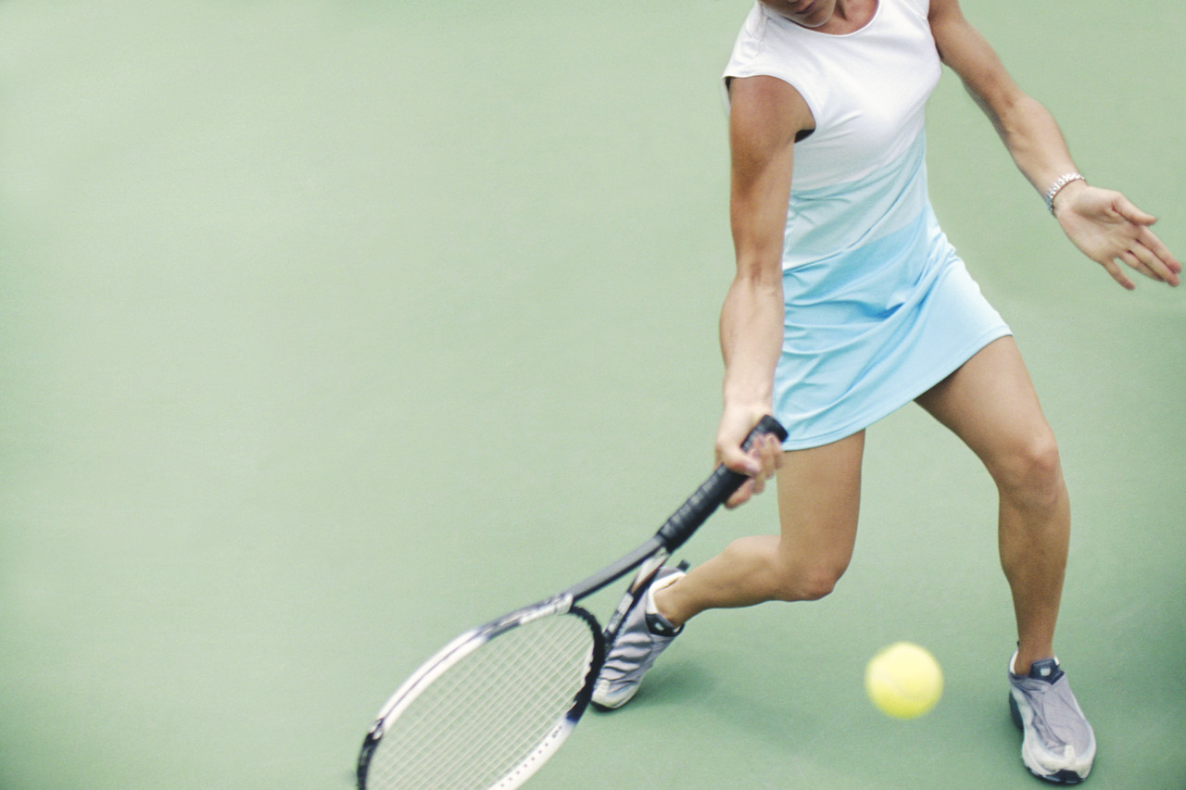
- sports – yes, tennis / books and magazines – no
not interested in
- relaxing / fun / enjoy
- play with friend Kate
- on Saturday mornings
- at the City Sports Centre

- - - - - - - - - - - - - - - - - - - - - - - - - - - - - - -
2B
- which activities / prefer ?
- why / like ?
- who / with ?
- when ?
- where ?

3A

- sports – no, boring / music – important to me,
relaxing
- play piano and guitar /
sing pop music
- practise on Tuesdays and Wednesdays
- at Tina´s Music School

- - - - - - - - - - - - - - - - - - - - - - - - - - - - - - -

3B
- which activities / prefer ?
- why ?
- which / musical instruments / play ?
- when / practise ?
- where / practise ?

4A

- travelling – yes, love / sports – no, not
important to me
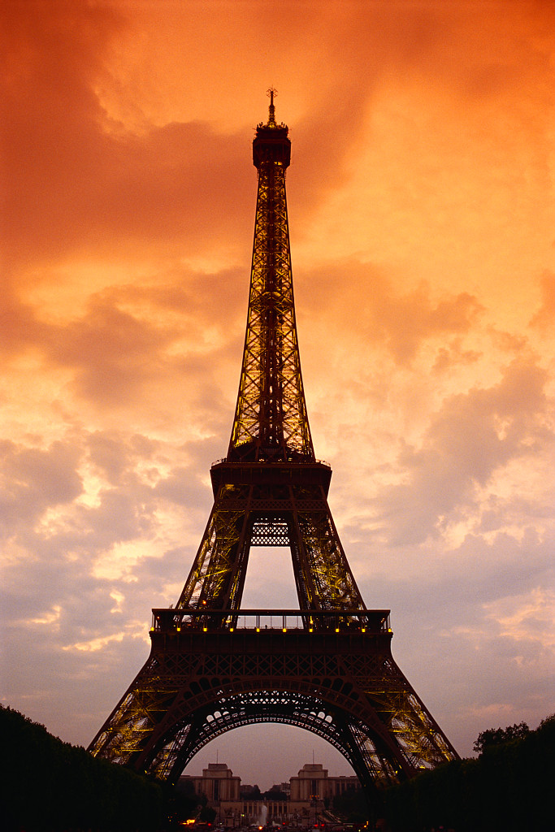
- visited Italy, France, Spain
- last summer / Spain, Bacelona
- travel with family
- visit museums, galleries, restaurants /
swim / sunbathe

- - - - - - - - - - - - - - - - - - - - - - - - - - - - - - -

4B
- which activities / prefer ?
- ever visit / foreign country ?
- when / where / visit ?
- who / travel with ?
- what activities / do ?

5A
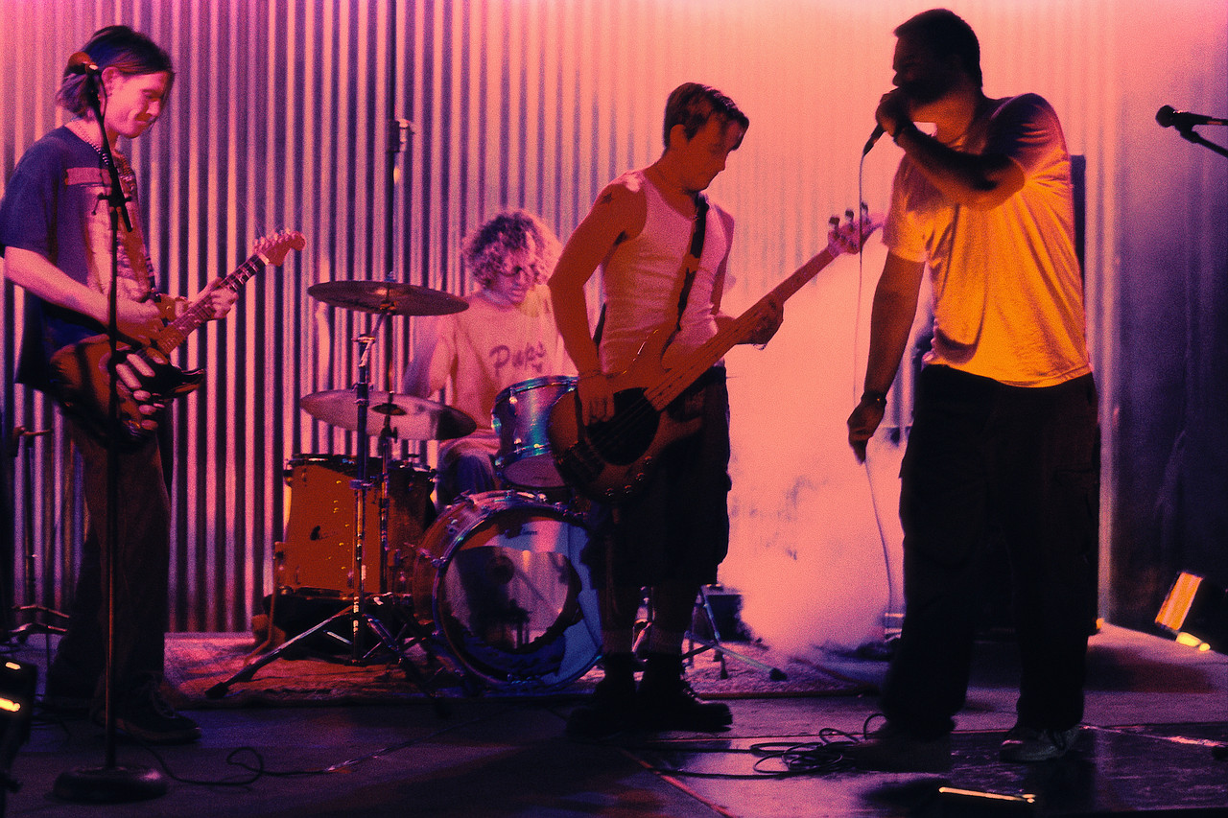
- animals – no, not interested in / music – yes,
important
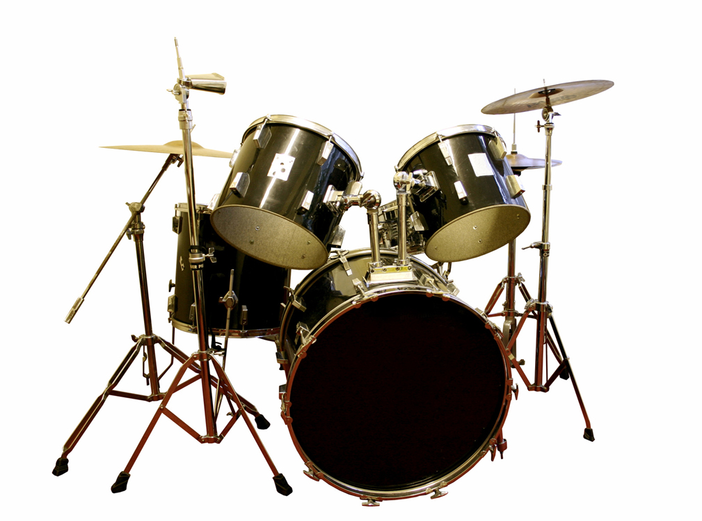
- relaxing / prefer pop and
rock music to classical music
- play drums and bass guitar
- band called ´Rockets´ / look for a pianist
- practise every day
- - - - - - - - - - - - - - - - - - - - - - - - - - - - - - -
5B
- which activities / prefer ?
- why / like ?
- play a musical instrument?
- have a band ? / name?
- when / practise?

6A

- literature – yes, books, enjoy / sports – yes,
but not important

- relaxing / fun
- every evening in bed
- at the moment / Eragon – fantasy novel
- read an English book - the Jungle Book

- - - - - - - - - - - - - - - - - - - - - - - - - - - - - - -

6B
- which activities / prefer ?
- why ?
- when ?
- read a book / at the moment ?
- ever read an English book ?

7A
- art – yes, painting, interested in / sports –
yes, swimming, basketball, but not into


- interesting / relaxing / go to an art school
- portraits / animals
- art school / every Tuesday
- have an exhibition / in your school gallery
- - - - - - - - - - - - - - - - - - - - - - - - - - - - - - -
7B
- which activities / like ?
- why / art ?
- what / like to paint ?
- when / go to an art school ?
- ever / have an exhibition ?

8A

- enjoy sports – winter – snowboarding,
ice hockey / summer – jogging, cycling
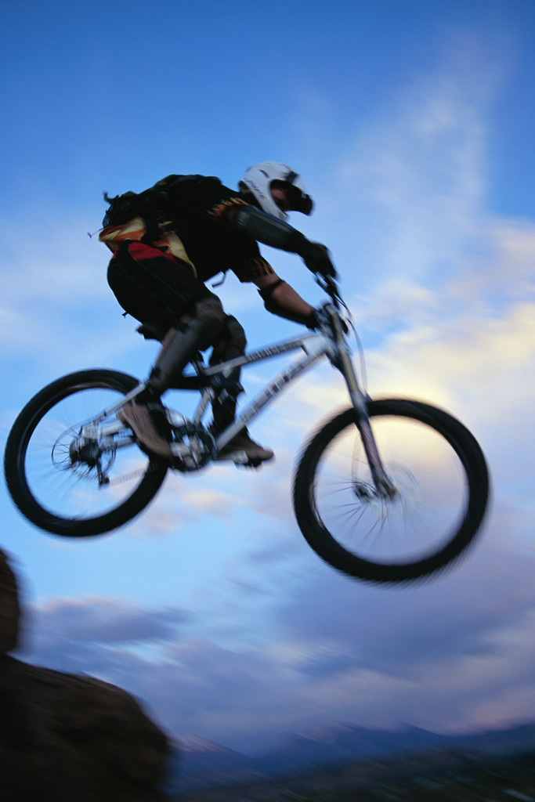
- relaxing and fun / meet friends
- snowboarding / with friends and cousins
- ice hockey, at the local sports centre
/ jogging, in the park, along the river
- never cycle in a race / just for fun

- - - - - - - - - - - - - - - - - - - - - - - - - - - - - - -
8B
- which activities / like?
- why / like ?
- who / go snowboarding with ?
- where / ice hockey / go jogging ?
- ever / cycle in a race ?

9A
- languages – yes, important to me / music – but
only listen to pop and rock / prefer dancing
- Spanish / French / Italian
- love travelling / want to work
in a travel agency
- go to a language school three times a
week
- been to France and Spain / Italy - next summer
holiday
- - - - - - - - - - - - - - - - - - - - - - - - - - - - - - -
9B
- what / free time?
- which / languages ?
- why / study languages ?
- go to a language school ?
- ever / be to a foreign country ?

10A
- fashion – yes, important / films – on my
computer

- want to be a fashion designer / read
fashion magazines
- yes / made two dresses
- after finishing homework / at weekends
- fashion show / no

- - - - - - - - - - - - - - - - - - - - - - - - - - - - - - -
10B
- do / free time ?
- why / fashion ?
- ever / make clothes ?
- when / make clothes ?
- ever / be to a fashion show ?

Základní škola Olomouc
příspěvková organizace
Mozartova 48, 779 00 Olomouc
tel.: 585 427 142, 775 116 442; fax: 585 422 713
e-mail: kundrum@centrum.cz; www.zs-mozartova.cz

Seznam použité literatury a pramenů:

HUTCHINSON, T. Project 5 – učebnice angličtiny. 3. vyd. Oxford : OUP, 2009. 79 s. ISBN 978-0-19-476418-6. s. 6-7.

HUTCHINSON, T. Project 5 – Pracovní sešit. 3. vyd. Oxford : OUP, 2009. 80 s. ISBN 978-0-19-476362-2. s. 2-3.

Použité zdroje:
Obrazový materiál je použit z galerie obrázků a klipartů Microsoft Office.

Nečíslovaný obrazový materiál je použit z kolekce programu Microsoft Word.

